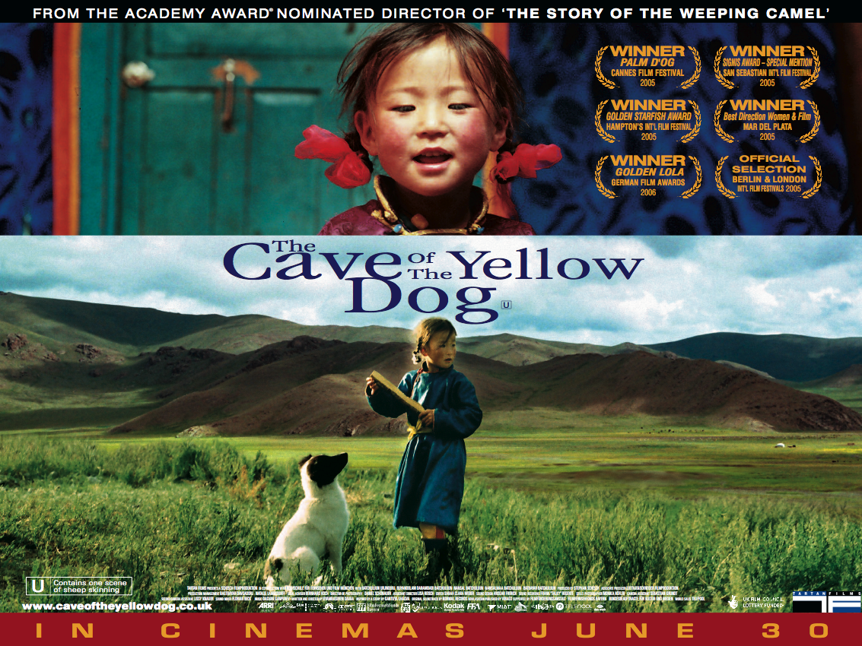

Teachers’ Notes

The Cave of the Yellow Dog educational resource is aimed at Key Stage 2 teachers of Literacy, Geography, Religious Education and P.S.H.E. & Citizenship. It contains activities that look at the following themes and issues:

- Friendships and Relationships
- The Nomadic Lifestyle
- Traditions, Values and Beliefs
- Urbanisation and Modernisation
- Looking at Documentaries

Film Synopsis & Press Notes

A Mongolian nomad family find themselves in disagreement when the oldest daughter, Nansal, finds a dog and brings it home. Believing that it is responsible for attacking his sheep, her father refuses to allow her to keep it. When it’s time for the family to move on, Nansal must decide whether to defy her father and take her new friend with them. The Cave of the Yellow Dog is a thought provoking mix of documentary and drama that tells the story of the age-old bond between man and dog, a bond which experiences a new twist through the eternal cycle of reincarnation in Mongolia.

Directed by: Byambasuren Davaa
Certificate: U (Contains one scene of sheep skinning)
Running Time: 93 minutes
UK release date: 30th June 2006

The Press Notes for The Cave of the Yellow Dog can be downloaded from the Film Education website at www.filmeducation.org/cave/synopsis.html

Additional teaching notes and background information on Mongolia can be found at www.filmeducation.org/primary/weepingcamel/desert.html as part of Film Education’s resource for The Story of the Weeping Camel, Byambasuren Davaa’s first film, released in 2003.

Friendships and Relationships

The Cave of the Yellow Dog follows the story of a six-year old girl, Nansal, and her relationship with Zochor, a small dog that she finds in a cave. Nansal forms an attachment with the dog and takes him home to her family. Unfortunately, Nansal’s father refuses to let her keep the dog but Nansal defies her father and hides Zochor in the animal pen.

Activities
- Look at the images of Nansal and Zochor together on the bottom of the film poster and image gallery (www.filmeducation.org/cave/gallery/). Why do you think Nansal wants to keep the dog? Make a list of your reasons.
- The director has focused the film around Nansal’s relationship with Zochor. Of all the relationships in the film why do you think this one is the most important? Watch the trailer at www.filmeducation.org….. and think about how the director shows the importance of Nansal and Zochor’s relationship.

The Nomadic Lifestyle

Nansal and her family are nomads. Nomads are communities or families who live in remote areas, away from cities and towns. The families live in round tent-like buildings called yurts or ghers which they can pack away easily when they travel to a new location. Nomads often move their houses to a different location so they can find a suitable place to herd their animals, which provide the family with food, milk and wool.

Activities
- When 6-year-old Nansal is not away at boarding school, her average day consists of the following activities:
  - Looking after her younger brother and sister
  - Collecting dung to fuel the family’s fire
  - Taking the family’s herd out to graze
  - Helping her mum make cheese
  - Helping to pack away the family’s yurt or gher (house) when the family move location
Write a list of the things that you do each day and compare your list to Nansal’s to see how similar or different your lives are. Which day would you prefer? Write an account of your preferred day and include how you would feel doing each of the activities.
- Imagine that a film crew followed you for a whole day. Create a storyboard to show the activities that they might capture on film.

Traditions, Values and Beliefs

“Everyone dies, but no one is dead”

Mongolian people have a strong belief in reincarnation. Reincarnation is the belief that when a person or an animal dies they will come back to life in a different body. In The Cave of the Yellow Dog the elderly lady that Nansal visits explains that although all people are reincarnated it is hard to be re-born as a human and that is why human life is so valuable. The lady also explains that only children can remember their past lives which is why they tell such colourful stories.

Activities
- Mongolia is traditionally a Buddhist country which is why many people believe in reincarnation or rebirth. Use the Internet and information books to find out more about Buddhist beliefs and reincarnation.
- Carry out research to find out which other religions also believe in reincarnation. Are there any differences in the concept of ‘reincarnation’ for each religion?

There are as many versions of a story as there are tongues telling it.

Mongolian people have a tradition of folktales which are passed on to the next generation through verbal re-telling. Every narrator embroiders the tale a little bit more, adding details that were not in the original tale or maybe forgetting a few original details. Mongolian folktales can be roughly divided into four groups: legends, animal tales, tales about everyday life and magical and riddle tales.

Activities
- In The Cave of the Yellow Dog, Nansal meets an old lady who tells her the folktale about the Yellow Dog. The tale is about a girl who falls ill. Her father is told that for his daughter to get well again he must get rid of her yellow dog. The father cannot bring himself to kill the dog so he takes it to a cave, and seals the cave entrance with a boulder. The father goes to the cave everyday to feed the dog until one day the dog disappears. The daughter recovers from her illness, meets a young man (possibly the reincarnation of her dog) and falls in love.
- Why do you think the director chose to include this folktale in the film? After watching the film, think about how the folktale is similar or different to the film’s narrative. What meaning does the fable add to the film?
- Use the Internet to find out more about Mongolian folktales. Find an example which you would like to develop into a film and design a film poster to promote your film. Your poster will need to be eye-catching and contain images which give clues to the film’s narrative.
- Do you think filmmakers are modern day storytellers? Discuss the arguments for and against this theory.

Urbanisation and Modernisation

The Cave of the Yellow Dog deals with the issue of the urbanisation and modernisation of Mongolia. Nansal’s family lifestyle is being influenced by the urban lifestyle as Nansal goes to school in the city and her father also travels to the city to sell sheepskins. Many nomadic families are moving to cities, which is increasing the problem of wolves attacking families’ herds, as there are fewer nomads to hunt the wolves.

Activities
- In the film The Cave of the Yellow Dog the director does not show any footage of city life but we see its influence on the nomadic lifestyle when the father brings home for his family some toys and a modern plastic saucepan from the city. We also learn more about what the city is like when Nansal tells her younger brother and sister about going to school there. Why do you think the director chose not to include footage of the city in the film? Do you think seeing the city through Nansal’s eyes would give the viewer a different perspective of the city than if they had viewed it themselves on film?

Looking at Documentaries

The Cave of the Yellow Dog is a mixture of documentary and drama. The director and crew spent over 60 days filming the family to get the footage they required to create the film. The family or ‘cast’ were filmed without having to perform to scripts as professional actors do. The director prompted the family to do the everyday things that come naturally to them.

Activities
- What do you think are the benefits of filming the family going about their natural everyday tasks? How do you think The Cave of the Yellow Dog would have been different if the family were given scripts and asked to act?
- Imagine a film crew came to your house to make a documentary about your family. How would you feel about your daily life being filmed for the big screen? Who would own the film: the director, the film company or your family?


More ‘documentary’ activities and tasks for The Cave of the Yellow Dog can be found on the London Film Festival website at http://www.lff.org.uk/content.php?CategoryID=687

