VIEWPOINT ACTIVITY SHEET 2

Oliver Twist in still, and moving, image
Look at these still images from the clip Oliver Twist: Opening sequence. Each still has text boxes for you to fill in. Use these to describe what we see in the shot, including what type of shot it is, and then explain how the shot type and camera angle encourages the audience to react to Oliver in a certain way at that moment.
Describe what you see in the shot and explain how the shot encourages sympathy for Oliver
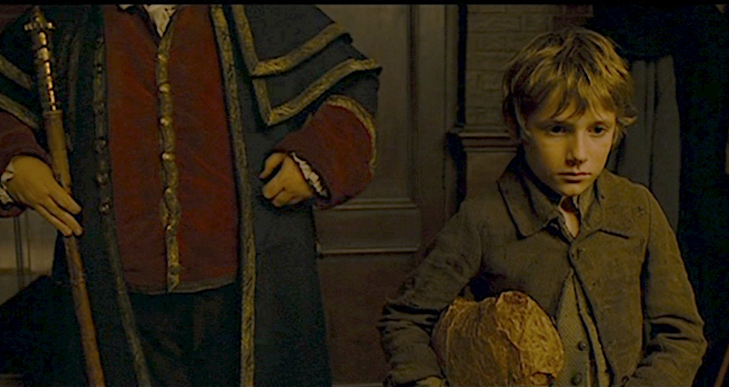
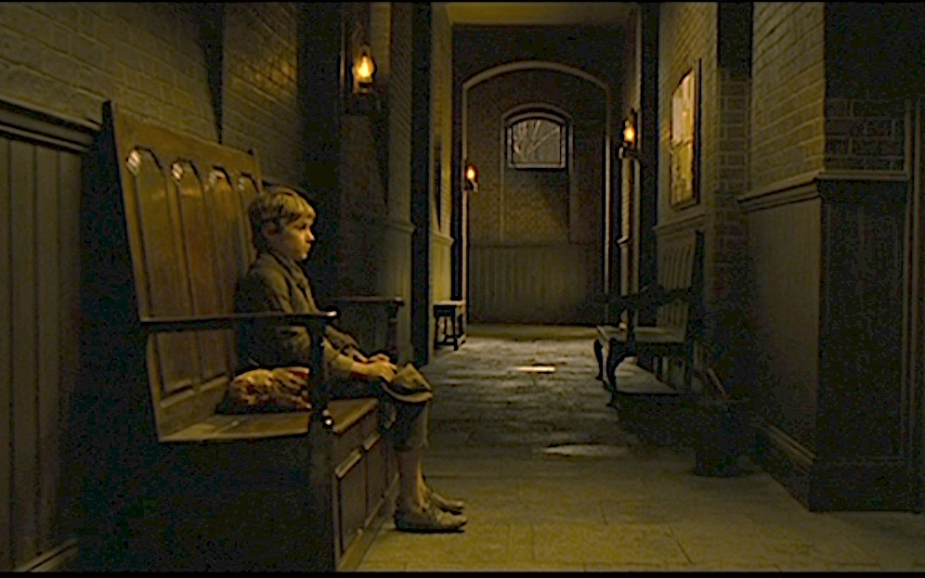
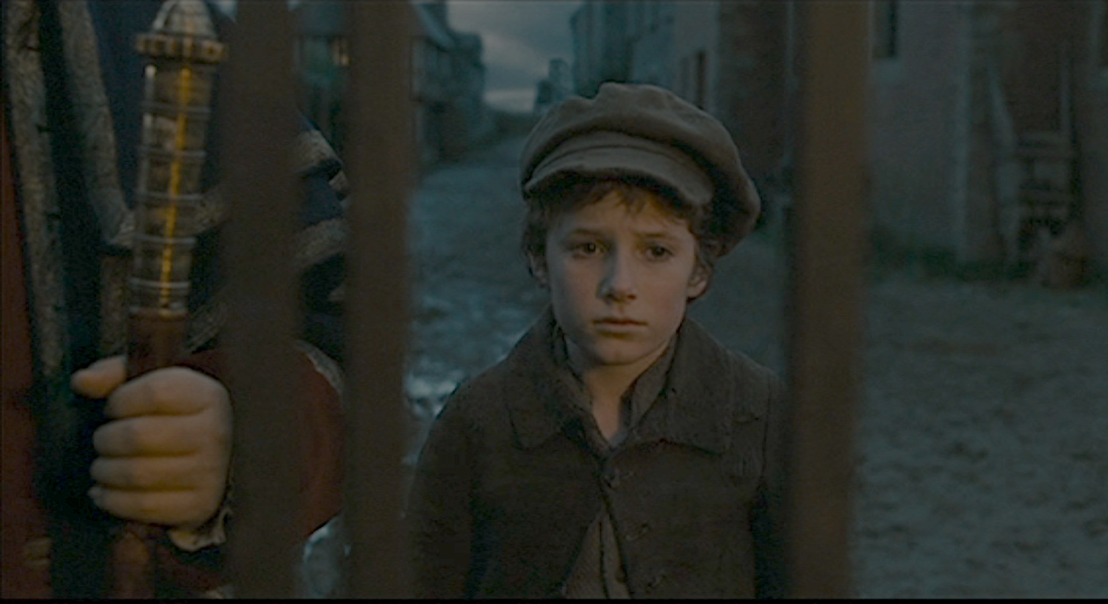
Describe what you see in the shot and explain how the shot encourages sympathy for Oliver

Describe what you see in the shot and explain how the shot encourages sympathy for Oliver

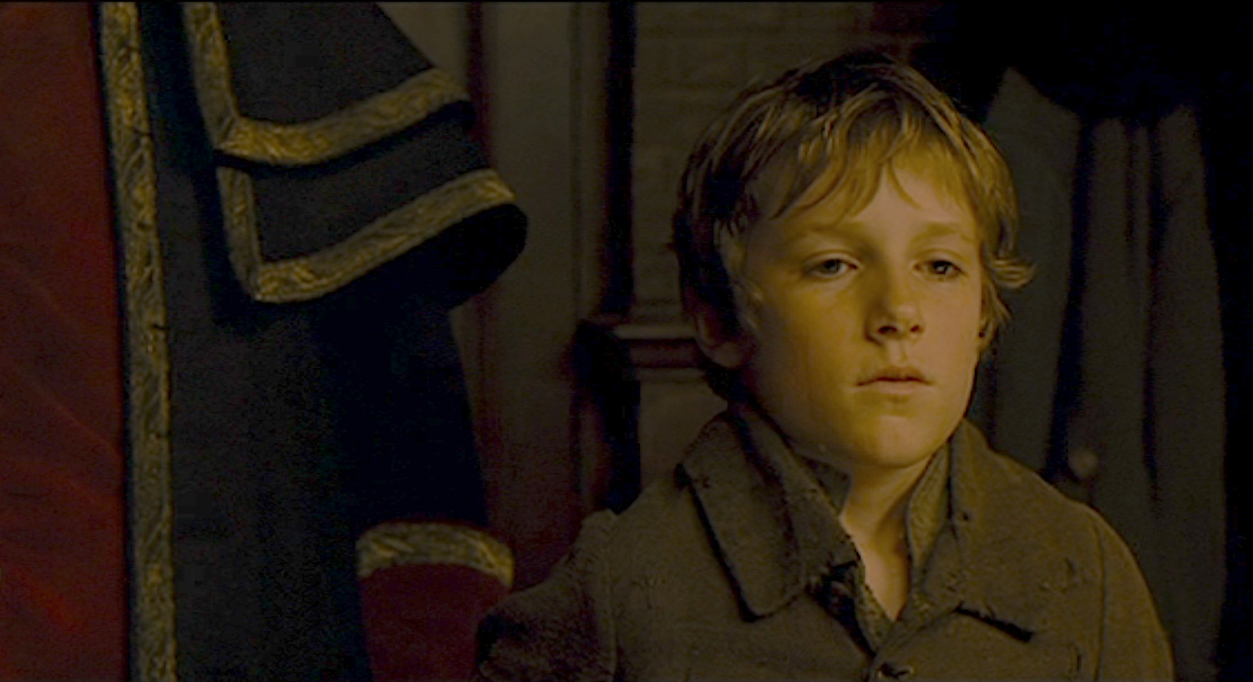
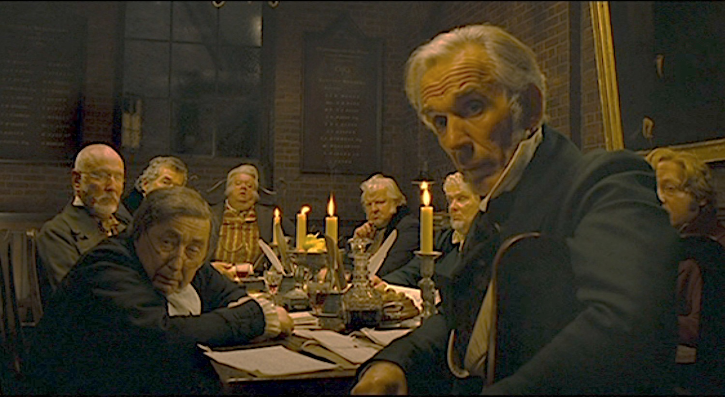
Describe what you see in the shot and explain how the shot encourages sympathy for Oliver

Describe what you see in the shot and explain how the shot encourages sympathy for Oliver

VIEWING ACTIVITY
Now, watch the sequence Oliver sets out, which is taken from slightly later on in the film.

- In what ways are we encouraged to sympathise with Oliver in this sequence? Think about the way the filmmakers have put the sequence together, thinking particularly about camerawork and editing.

- How far would you agree that we share Oliver’s viewpoint in this clip? Explain your answer, using examples from what you see and hear in the sequence.

