EDITING

You might think that all the art of filmmaking takes place in front of and behind the camera. But a lot of art also goes into the editing process where the final film is put together. Editing a film involves selecting and combining shots into sequences and combining these sequences to create a finished film. This deliberate process helps create the filmic world and make meaning in the film. Good editing is a critical element in getting the audience to understand the film’s story, by creating or enhancing mood, emotion and character.

The director needs to create enough shots for the editor to choose from to tell the story. Not even a great editor can save a badly shot film. But give the editor a well-shot film and they might work with the director to transform it into a masterpiece. The editor has a number of tasks on a film:

- To select and reject footage filmed by the director.

- To organise the various shots filmed by the director into a coherent whole.

- To co-ordinate one shot with the following shot in order to produce the desired effect on the audience and to keep a narrative moving.

BUILDING BLOCKS

The editor starts by looking at the various individual shots available to create a particular scene.

Using the script as a guide, they then decide how best to use these shots to construct the scene. A scene is a self-contained, continuous series of shots which show a particular dramatic and/or narrative moment. Sometimes, an entire scene might just comprise a single shot if it is an appropriately long take.

The editor adds one scene to another to form a sequence, which is a self-contained group of sequential scenes grouped around a specific set of sections of the narrative. Editing all of the sequences together will finally give us a finished film.

CONTINUITY EDITING

Despite all this art and craft, the audience hardly ever notices good editing. Although we know that we are watching pieces of film joined together, we are so used to continuity editing that we accept what is happening on screen providing that it follows the rules that we have learnt through watching other films or narratives. Most films and other moving images that we watch conform to this method of editing.

The common features of continuity editing, that we so often do not notice include:

Establishing shot
This is typically used at the beginning of a film or sequence to ensure that the audience know where and when the action takes place. We could see the outside of a building, landscape or a city skyline. This shot may then change to the inside of a building that we can assume for example is the inside of that building that we saw in the establishing shot.

Shot reverse shot
This is commonly used during conversation, it makes sure that we the audience can see how both people in the conversation respond and deliver specific pieces of information.

180 degree rule
This basic rule ensures that the audience can understand the scene in terms of where things are within the filmic space. For example, two characters (or other elements) in the same scene should always have the same left/right relationship to each other. If the camera passes over the imaginary axis connecting the two subjects, it is called crossing the line. The new shot, from the opposite side, is known as a reverse angle.

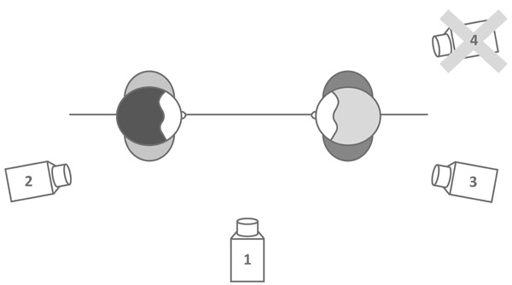

Rules can be broken, of course and if a director and editor break the 180˚ rule by choice, it is to create confusion and disorientation in either the characters or the audience.

CUT

When the editor is thinking about which shot to choose, they might find that the director filmed one piece of action from a number of different positions or angles. Which is the one that is right for the sequence?

In joining one shot to another, how should the editor cut?

Film editors can connect scenes in a number of ways. The most common transitions you will see include:

- A straight cut

- A fade out

- A dissolve

- A wipe cut

- A jump cut

These transitions affect the pace and mood of the scene and how the sense of the film is communicated to the audience.

You can show a scene in a single shot, so why cut from one shot to another in a scene? What is the effect of this?

SPACE, TIME AND RHYTHM

When the editor works on a scene, they are thinking about three things:

- Quality of the shot – what does each shot contain? How has the cinematographer filmed each shot? Is it a close-up, a long shot etc.? What is actually happening in the shot? What are the characters doing? How does this relate to the way that the shot has been filmed?

- Cinematic space – effectively where the action takes place. It is quite common to begin a sequence with an ESTABLISHING SHOT which establishes the place where the action takes place, spatial relationships between actors and objects within that space and the scale of the cinematic space (i.e. does the action take place in a small room or in a wide landscape?). It also asks the audience to think about what people are doing within this space and what we want to focus on.

- Cinematic Time – the time a given sequence takes to play on the screen. In film, time can be compressed or extended. Although the action might take only a few seconds, through editing and building up tension, the cinematic time of your final film might be longer. The opposite might be the case. Although the action itself in real time might be for five or six minutes, in cinematic time you might be able to edit the scene in one or two minutes.

How to shrink time
Through a series of fast paced cuts we can see things that would take a long time in just a few minutes or seconds. Instead of watching a character get in a car and drive for 20 minutes we see them get in and then get out, letting us assume that the journey has taken place.

How to expand time
The editor can expand time by adding additional details. For example, someone is sitting in a chair waiting for the phone to ring. In real time this might only last half a minute. But the editor can build up tension by including shots of the person’s eyes, tapping fingers (to show impatience) etc., drawing the scene out to a minute or more. We are looking at “film” time, not real time.

Rhythm
Editing sets the rhythm or pace of a scene. This could be dictated by either the music used behind a scene or the mood that the editor is trying to create and the pace that you edit. To build up tension in a scene you might cut from one shot to another very quickly. However, in a relaxed scene the editing will progress at a much slower pace, dwelling longer on each shot.

ACTIVITY

Editing is something of an ‘invisible art’, because we rarely notice the cut between one shot and another.

Look at a 3-minute extract from any film. Watch the extract through once quickly and estimate how many edits there are in the piece. Now watch it again and mark down each time an edit occurs. Did you underestimate the number the first time you watched the extract? That’s the power of the ‘invisible art’!

So we could say that we start with the shot, we then decide what is happening and where it is happening. Then we need to think about the mood of the sequence and how this should be reflected in the way that we cut the shots together. Finally, what is the rhythm of the piece? Are we trying to create tension – and if so do we use lots of shots or only a few?

