APPROACHING FILM IN HISTORY
FILM LANGUAGE

THEORY

In order to analyse films confidently and meaningfully, you need to have a rudimentary grasp of film language. This help-sheet provides you with key terminology for analysing moving images. By having an awareness of these terms and concepts, you will be better able to articulate your ideas and opinions in discussion and writing.

SHOT TYPES
These terms describe the camera’s viewpoint and show the effect this might have on the audience. The following examples are taken from the clip of Fateless on the DVD.

Long shot – shows background, establishes where you are.

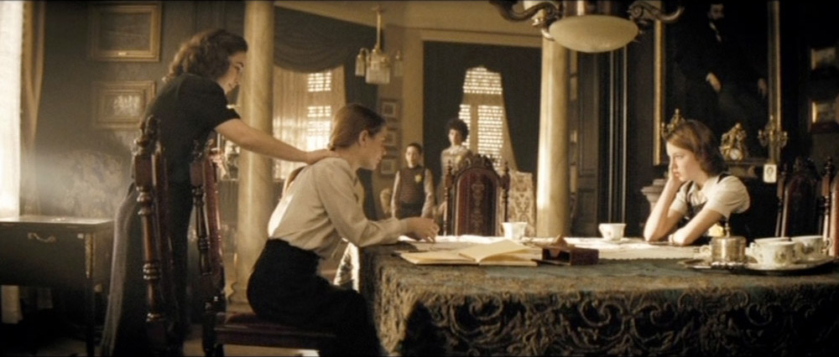

Mid shot – shows torso and some background.
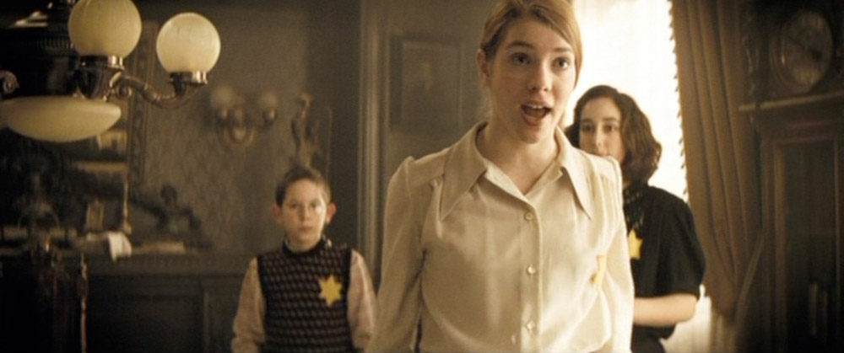
Close-up – head and shoulders, usually used to show emotion. Draws our attention to face or object.
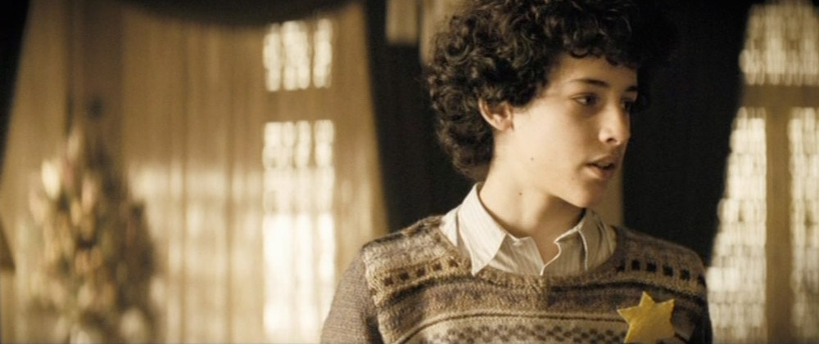

Over the shoulder shot – used when two characters are interacting face to face.

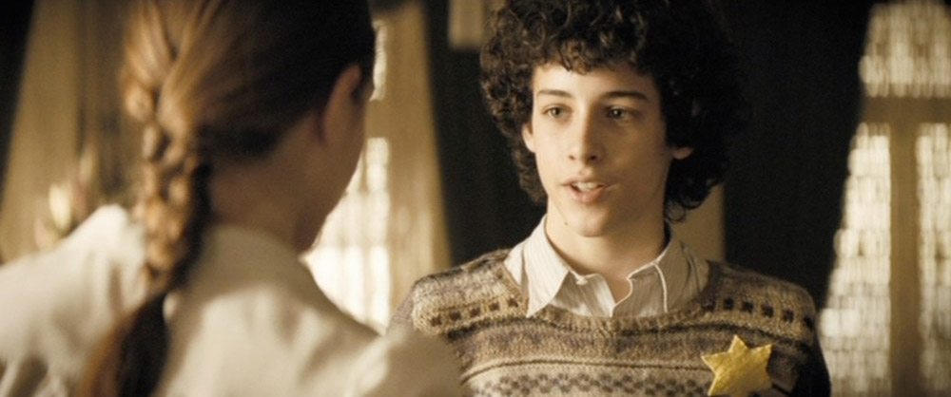

Point-of-view shot – helps us to see the action from a character’s viewpoint and thus empathise with them.

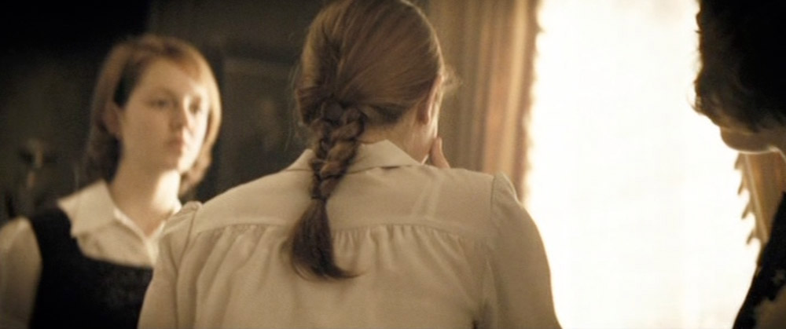

High angle shot – camera looks down on person/object, making them look vulnerable.

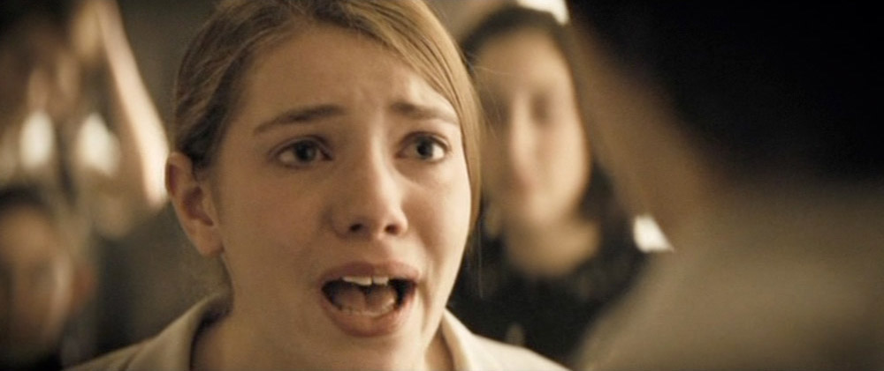

Low angle shot – camera looks up at someone/thing, making them appear powerful.

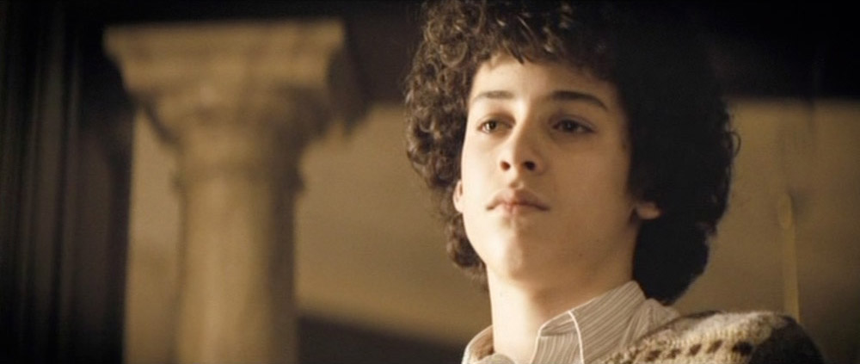

CAMERA MOVEMENT
The way in which a camera is moved can be used to direct our attention to emphasise a particular viewpoint. Camera movements include:

Panning shot – the camera moves slowly across from side to side from a fixed axis

Tilt shot – the camera moves up and down from a fixed axis

Crane shot – the camera, mounted on a crane, moves around at a distance above ground level.

Tracking shot – the camera follows the action, moving along tracks laid for that purpose, often pulling backwards from a scene.

Hand held – this technique is often used to suggest a greater sense of authenticity, for example it could be used to be used to provide ‘eye witness’ accounts of situations, linked to the point of view of a particular character or characters.

MISE EN SCÈNE
This term is used in film to describe what is in the frame and why. There are several areas to consider when talking about mise en scène:

- Setting and props
- Costume and make-up
- Body language and facial expression
- Lighting and colour

Each of these factors combines to give the shot a certain “look” or “feel”. What is put in or left out of a shot can make a big difference to the signals we receive about what sort of film it is and how we are supposed to feel at this point. For instance, a simple shot of a tree can be made to look threatening by adding a vulture and a storm and shooting it in darkness. The same tree can be given a very different look by having children playing beneath its sunlit branches.

LIGHTING
Lighting quickly creates an atmosphere on screen. If it is dark and shadowy we might be made to feel uneasy, as in a thriller; if the lighting is bright we feel happy and confident. The filmmaker can use lighting to draw our attention to a person/object or equally, to hide them.

SOUND
There are three elements to a film soundtrack:

- Dialogue – this can be used to give us clues as to character and what might happen next.

- Music – this creates atmosphere, affecting us on a very emotional level.

- Sound effects (SFX) – again, very effective at creating atmosphere. These sometimes do not fit with the image that we are seeing, thus creating a disorientating effect.

EDITING
The term editing refers to the changing shots within a piece of film. The speed with which this happens has important role in creating atmosphere. For instance, if there is a car chase on screen, the editing will be rapid, making us excited. A countryside picnic scene, on the other hand, will probably feature slow editing, we relax and take in the details on the screen.

TITLE GRAPHICS
The way in which the title and credits of a film are written and the colours chosen for both them and the background tell us what type (genre) of film to expect. A horror film might employ a red Gothic font, whereas a science fiction film may use a bright green colour on a black background.

PRACTICE – SEQUENCE ANALYSIS

This activity is designed to give you confidence using the film language outlined above.

As you watch one or more of the following clips, try to answer as many of the questions as you can in your group. Where you would need to undertake research, make a note of what you need to find out and where you plan to look.

- The Boy in the Striped Pyjamas – clip 3
- Judgement at Nuremberg – clip 9
- Into the Arms of Strangers – clip 12

What is the film about?

- How has the filmmaker shown what is happening in the sequence. What has been emphasised and from whose point of view?

- From the way the film is shot, how do you find out about the characters, their relationship and their actions in the sequence?

- What kind of production does this seem to be, and what genre does this sequence seem to belong to? Explain your answer, describing any genre features you can identify in this extract.

- What questions would you want to ask about the rest of the film? Based on what you have seen, what predictions might you make about narrative events that have already occurred and developments following this sequence?

- In what ways does the sequence highlight any key themes or ideas about the Holocaust?

- From watching this sequence do you feel that the film has a 'message' for its audience – is it trying to put across particular ideas or viewpoints? Explain your answer.

How is meaning created in this sequence?

- How do setting, location, props and costume choices contribute to your interpretation of the sequence? Consider what information these convey.

- How does the sound shape your responses to the sequence? Comment on dialogue, tone, incidental sound and any music you notice, exploring their impact on your emotional response to the sequence.

- How do lighting and colour affect tone and atmosphere? Explore lighting choices, including noticeable use of light and shadow, as well as considering choice of colour.

- How does camera technique contribute to the creation of meaning in this sequence? Consider the effects of camera position, movement and angle.

- Consider the ways in which the editing might affect our interpretation of what we see in this sequence. How important are pace and continuity in shaping your response to what you see?

Why would you watch it?

- Whose viewpoint do we see in the sequence and why might this be significant?

- Why do you think the director chose to film the sequence in this way? How else could he or she have directed it?

- What do you learn (if anything) about the Holocaust from this sequence?

