UP, PETER DOCTOR AND BOB PETERSON, 2009
‘Hi, master.’
Literacy Focus: Stories that raise issues or dilemmas.

Years 3 – 6 Literacy Plan: Stories that raise issues or dilemmas
Thinking Film Primary 3 weeks

CLIP CONTEXT
Inspired by the life-long wish of his now-departed wife, Carl Friedricksen is determined to take his house (which is floating due to the thousands of balloons attached to its chimney) to the wilds of South America. His journey is hampered when he picks up Russell, an eager boy scout, Dug the talking dog and an out-size exotic bird, christened Kevin by Russell.

On-going: The Thinking Film Working Wall: We recommend that space is provided for a ‘Thinking Film’ Working Wall / display where children can add words, images and thoughts. This will help visual learners to consolidate the Literacy themes covered in this unit.

WEEK BY WEEK OUTLINE
Prior Learning: Understand how character’s actions are determined by the dilemmas they face in the story. Understand what is meant by ‘dilemma’.
Week 1: What next?: predict how each character will react to the dilemma.

Week 2: Different viewpoints: explore how each character in the clip feels about the sequence of events.

Week 3: Mr Friedricksen’s fix: create a story graph showing why Carl Fredricksen behaves the way he does.

NB: The ‘MUST, SHOULD, COULD’ CATEGORIES REFER TO THE DIFFICULTY OF THE ACTIVITY (e.g. MUST = easy; SHOULD = medium; COULD = hard)

Objectives | Whole class activities | Differentiated independent or group activities | Plenary / focused questions | Success Criteria  Children can:
Week 1  WHAT NEXT?  Focus: predict how each character will react to the dilemma | Days 1&2:  Watch the clip and pause it at the moment when Carl’s house crashes into the rock and he turns on the other three angrily.  Ask children to think about how each character will react to the dilemma of the house being damaged and Carl wanting to continue the journey.  Give a copy of the image (Appendix 10) to each group of 4 or 5 children. They are to stick the image onto a piece of A3 paper and draw thought bubbles from each character. They will then add the thoughts of each character into the speech bubble.  Days 3 – 5  Explain that children will work in pairs. They will take it in turns to pretend to be one of the characters whilst the other one acts as ‘Agony Aunt/Uncle’ – giving advice as to how they should react to the dilemma (e.g. apologise and help Carl…) | Days 1 – 2:  MUST: Write a sentence that describes the thought processes of each character in the picture  SHOULD: Write a sentence that describes the thought processes of each character in the picture. Include a sentence that explains what they will do next.  COULD: Write a sentence that describes the thought processes of each character in the picture. Include a sentence that explains what they will do next. Add a speech bubble that shows what they might say.  Days 3 – 5:  MUST: Work in groups to act in role as Carl and Russell, whilst the other one is the Agony Aunt or Uncle.  SHOULD: Work in groups to act in role as Carl, Russell and Dug whilst the other one is the Agony Aunt or Uncle.  COULD: Work in groups to act in role as Carl, Russell, Dug and Kevin whilst the other one is the Agony Aunt or Uncle. | Days 1&2:  Each group to share their predictions.  Days 3 – 5:  Watch the best ‘role players’, decide on the best advice to give in this situation.  Watch the rest of the clip! | Discuss how characters deal with dilemmas

Objectives | Whole class activities | Differentiated independent or group activities | Plenary / focused questions | Success Criteria  Children can:
Week 2  DIFFERENT VIEWPOINTS  Focus: explore how each character in the clip feels about the sequence of events. | Watch the clip in its entirety.  Discuss the actions of each character. Why do they behave this way?  Explore what this tells us about their personalities.  Explain that the task is to create 4 character profile posters (see appendix 11) which include an image and a ‘most likely to say’ tagline.  The poster tagline should focus on what they would say in defence of their actions in the clip e.g. Dug: “I always bring the ball back to my master! I love my master!” | MUST: Draw a large image of Dug the dog and Russell, including what they are most likely to say to defend their actions in the space provided.  SHOULD: Draw a large image of Dug the dog, Russell and Kevin including what they are most likely to say to defend their actions in the space provided.  COULD: Draw a large image of Dug the dog, Russell, Kevin and Carl including what they are most likely to say to defend their actions in the space provided. | Share poster designs and have children act out the words in the character voices (apart from Kevin!).  Discuss how the children themselves would deal with the grumpy Carl and his dilemma. | Discuss how characters deal with dilemmas  Create a role in response to a dilemma

Objectives | Whole class activities | Differentiated independent or group activities | Plenary / focused questions | Success Criteria  Children can:
Week 3  MR FRIEDRICKSEN’S FIX  Focus: create a story graph showing why Carl Fredricksen behaves the way he does. | Watch the clip again. Focus on the character of Carl. Why is he so grumpy?!  Watch the clip again, this time pausing at everything that happens which irritates Carl and fuels his mood e.g. Dug, Kevin and Russell arguing; the house getting damaged; Russell asking ‘why?’; the house clips the tops of the trees; he slips into the stream; he walks into a cloud of bees; the branch he’s holding onto breaks; Dug turns up with the ball; Kevin squawks at him and finally, Dug puts the soggy ball in his hand!  Explore how the clip uses the Film High Five elements to build the tension and humour.  Explain that the children will be creating story graphs showing each of the moments that serve to make Carl grumpy! | MUST: Write a list of at least 3 things that happen to Carl that make him cross.  Create a story graph with time as the x axis, and Carl’s grumpy moments as the y axis. Plot the listed points on the graph.  Come up with a joke or happy thought to cheer Carl up!  SHOULD: Write a list of at least 6 things that happen to Carl that make him cross.  Create a story graph with time as the x axis, and Carl’s grumpy moments as the y axis. Plot the listed points on the graph.  Come up with a joke or happy thought to cheer Carl up!  COULD: Write a list of the ten things that happen to Carl that make him cross.  Create a story graph with time as the x axis, and Carl’s grumpy moments as the y axis. Plot the listed points on the graph.  Write down what you think Carl might say to the other characters next! | Share graphs. Discuss an alternative ending: for example, what would Carl have done had his wife been travelling with them? | Discuss how characters deal with dilemmas  Re-tell a story using headings  Plot key elements from the story on a graph

APPENDIX 10: IMAGE FROM ‘UP’

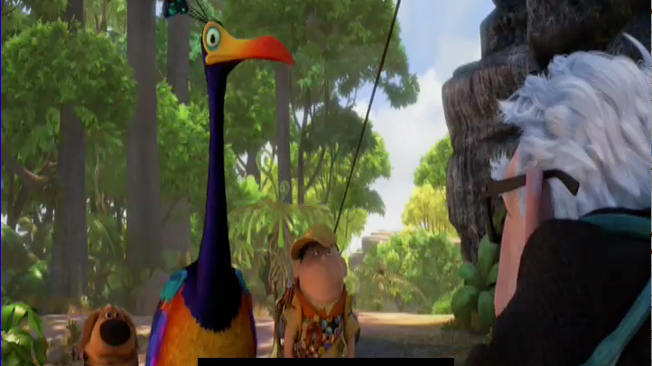

APPENDIX 11: CHARACTER PROFILE POSTER

Most likely to say…

