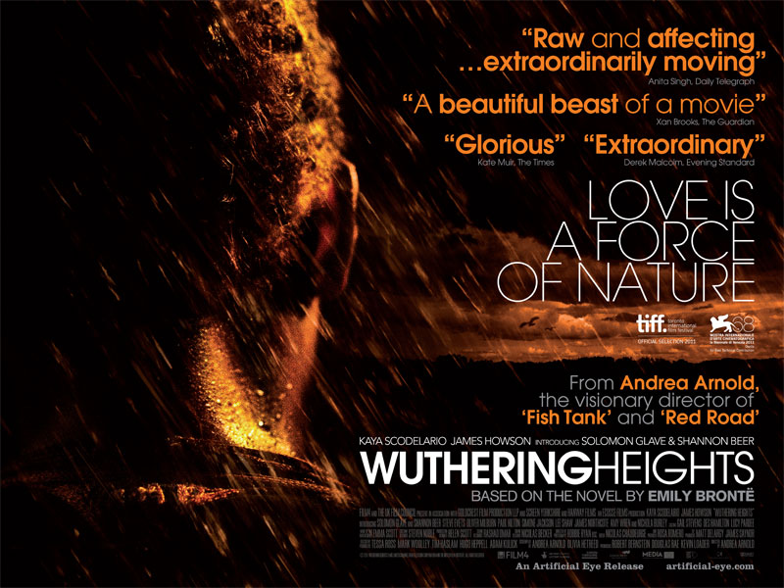

Teachers’ notes
This study guide exploring Andrea Arnold’s film Wuthering Heights is suitable for English Literature students and can also be used with students of Film and Media Studies at AS/A2 level and equivalent. Activities here are supported by key clips and the film’s trailer online at: http://www.filmeducation.org/wutheringheights

Film synopsis
A Yorkshire hill farmer on a visit to Liverpool finds a homeless boy on the streets. He takes him home to live as part of his family on the isolated Yorkshire moors where the boy forges an obsessive relationship with the farmer’s daughter.
Why ‘Wuthering Heights’?
At over 160 years old, the novel ‘Wuthering Heights’ has what you might call ‘cultural capital’ – it is widely known, generally considered a classic of English literature and is studied by students throughout the UK and overseas as part of school examinations and university courses. The story has inspired a range of creative responses over the years, some of which are referred to in this extract from the new film’s official Press Notes, which are given to journalists and others who see the film at preview screenings to give them background on the production:

* Note on the cultural phenomenon of ‘Wuthering Height’s:
Since its publication in 1847 Emily Brontë’s only novel ‘Wuthering Heights’ has been one of the most widely read, analyzed and influential works of literature in the world. It has inspired a multitude of creative outpourings including dramas, poems, ballets, operas (one of them by the legendary film composer Bernard Herrmann). The earliest known film adaptation was made by A.V. Bramble in 1920, although no surviving prints of it are thought to exist. Luis Bunuel made a Spanish Catholic interpretation -- Abismos de Pasion (1954) set in Mexico. Jacques Rivette’s Hurlevent (1985) transported Bronte’s characters to the French countryside of the 1930s. An adaptation by Yoshishige Yoshida, Arashi ga Oka (1988), is set in feudal Japan. The most famous version is William Wyler’s 1939 film, the romantic Hollywood classic starring Olivier and Oberon. The first television adaptation was made by the BBC in 1948, followed by a score of others including an MTV re-interpretation set in a California high school. References to Wuthering Heights abound in popular culture, from the Kate Bush song to Monty Python, Japanese manga, an internet role-play game and the phenomenally successful Twilight series of books and films.

- Why do you think this background information about adaptations of the novel was included in the official Press Notes for this film?
- Have you heard of any other recent film adaptations of classic novels? As a group, make a list. You can go back a few years if you need.
- What reasons can you think of as to why filmmakers return to works of literature such as this when they are making a new feature? Think about the different reasons that the director, the producer and the actors might have for getting involved with such a production.

The director’s vision
Andrea Arnold is a British director whose films have received prizes and critical acclaim. The Press Notes give some details of her career:
Andrea Arnold – Writer/Director
Arnold’s second feature film Fish Tank, was awarded the Jury Prize at the Cannes International Film Festival 2009.

Red Road, her first feature, also won the Jury Prize in Cannes 2006.

Arnold previously made three shorts. Wasp won the Academy Award for Best Live Action Short in 2005, Dog and Milk were both selected for the Semaine de la Critique in Cannes in 2003 and 1998.
You can find out more about the director and her previous films online, for example in this interview in The Telegraph:
http://www.telegraph.co.uk/culture/film/filmmakersonfilm/8870091/Dark-depths-of-Andrea-Arnolds-Wuthering-Heights.html

- What are your expectations of a film adaptation of a ‘literary classic’, or of a film in the ‘period drama’ genre?
- What expectations might you have of a film by director Andrea Arnold?
Now read these extracts from the Press Notes:
“I have never liked the idea of adaptations,” says WuthERing heights writer-director Andrea Arnold. “A book is such a different language to film and they are often complete as they are, so I have really surprised myself by attempting one. And what a book to pick”, she wryly acknowledges. “It's gothic, feminist, socialist, sadomasochistic, Freudian, incestuous, violent and visceral. Trying to melt all that together into a film is an ambitious and perhaps foolish task. Any attempt will never do the book justice. But it was like I had no choice.”
Producer Robert Bernstein:
“Our goal was to facilitate Andrea’s vision because she is a very distinctive author-director. Authenticity and truthfulness are very important to her and I think that comes across in all aspects of the film. It has a grittiness and a realness about it, which is interesting in a period piece, and is very much what it would have been like. We set out to make a provocative piece and that’s what we’ve got.”
- Based on these quotations, and from looking at the film poster on the cover of this guide, what do you expect from Andrea Arnold’s ‘provocative’ production?
- What do you think Bernstein means by ‘authenticity’ and ‘truthfulness’ here?
- Do you think that what seems ‘real’ to a cinema audience today is the same as what would have seemed ‘real’ to people at the time the novel was written (1847)?
- To what extent do you think a modern film director should make their own ‘version’ of a classic novel and to what extent do you think they should follow the original text? In your answer, try to think about what audience a filmmaker might be trying to appeal to.

Narrative choices, narrative frames
When studying the novel ‘Wuthering Heights’, students are often concerned with keeping track of the complex plot and the generations of characters. Aside from these plot elements, Emily Brontë’s novel is also concerned with creating atmosphere as well as dealing with broader ideas about society and human nature. When making a film based on a novel, a filmmaker has to make decisions about what to bring to the screen and what to leave on the page: as Arnold herself says, “A book is such a different language to film.”

- What options for telling a story does a filmmaker have available to them that are not possible in a novel?
- What sort of film style or techniques (in terms of location and setting, casting, cinematography, special effects, editing and so on) do you think would be most effective for bringing this story to a new audience? Once you have seen the whole film, consider what techniques Andrea Arnold makes use of that you find effective in creating character and atmosphere.
- How does Emily Brontë’s novel begin, and what narrative devices are used to reveal key events? Once you have seen Andrea Arnold’s film, compare how she chooses to open the action and structure the film’s narrative to the way the novel is structured and narrated.
Heathcliff
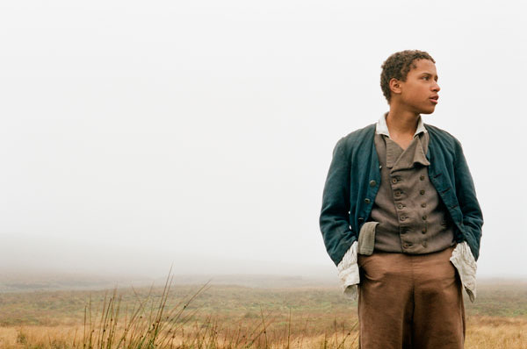
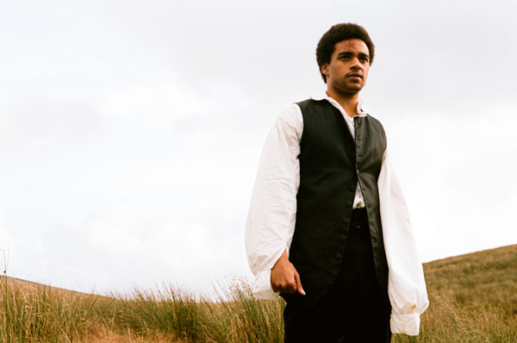
Images from the film showing Heathcliff as a boy and as an adult
Director Andrea Arnold explains her focus in creating her film from the characters and ideas in the novel:
“When I re-read it after many years I found myself fretting about Heathcliff. The ultimate outsider. A vertical invader. I wanted to make it for him. The way he was treated as a boy. The brutality. The way he then turns out. A product of his experience, or of his true nature? Cathy says she is Heathcliff. I think Emily was Heathcliff. I think we might all be Heathcliff.”

- In what ways might you expect this focus on Heathcliff to affect the way that the screenplay is adapted from the novel? What techniques might the director use in filming scenes with Heathcliff to help the audience focus on his character and empathise with him?
- How does Andrea Arnold’s explanation here compare to the way you respond to Heathcliff’s character in the novel? To what extent do you think it is possible for different readers to interpret novels in different ways?
- Consider the two images on page 5 of Heathcliff taken from the film, looking closely at details of costume, casting, expression, posture and location. What comments could you make on how the director has interpreted Heathcliff’s character?
- Now view the three clips on Film Education’s website and answer the accompanying questions: http://www.filmeducation.org/wutheringheights/clips.html

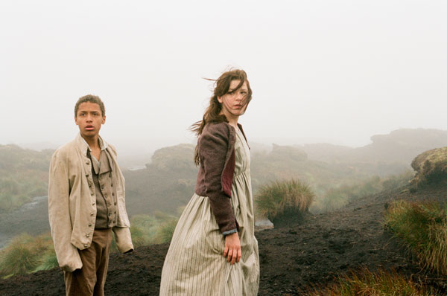
Worlds apart

In the film, Cathy takes Heathclliff out onto the heath on her horse shortly after he arrives, to comfort him and to share with him the natural world that she loves. Techniques such as slow motion, soft focus, and a soundscape of soft breathing, wind and birdcalls make the scenes on the heath sensuous and beautiful. But the heath is also wet, muddy and wild and Cathy and Heathcliff are frequently filthy in the film.

“Nature had to be part of my Wuthering Heights,” Arnold states. “I knew this without question from the start without knowing exactly why. Nature can be both beautiful and comforting but also brutal, selfish, furious and destructive. We are part of it, not separate from it, despite how we live. We are animals, and not always as in control as we think we are. Heathcliff is a force of nature. We all are. It had to have a big presence, be woven into every part of the film.”

The word heathen, as well as meaning a non-religious person, also translates as ‘heath-dweller’ and the contrast between the civilised society of the Lintons and the wild, filthy childhood of Cathy and Heathcliff at the Heights is a serious division.

“The world of the Grange is very much the 18th century one of civilized comforts while the Heights shows a way of life unchanged for hundreds of years. There’s no electricity up there and no running water. But those meadows are still farmed. It’s the hardest shoot I’ve ever been part of; there was a constant awareness of wind and water, the darkness and the harshness of the elements. But it brings home that kind of isolation and closeness to the natural world.”
(Robert Bernstein, Producer)

- Once you have seen the film, consider the portrayal of life at the home of the Lintons: the electric lighting and sparkling chandeliers, the musical instruments, the inhabitants’ clothing and their lifestyle. Contrast this with the depiction of life at Wuthering Heights. Which of these two representations of ‘period’ life seems most in keeping with other examples of period drama you have come across?

Modern classic
Use your viewing of the whole film, or a combination of the trailer and the clips on the website: http://www.filmeducation.org/wutheringhights/clips.html to draw together your responses to this film and to the questions below:

- Arnold uses a lot of close-up photography of the natural environment and of parts of the actors’ bodies. Soft focus, focus pulls and slow motion are all part of the photography and contribute to the creation of mood. How do you respond to this as you watch? In what ways could you compare the style of Andrea Arnold’s film to the main concerns of Emily Brontë’s novel?
- Do any aspects of the film seem distinctly ‘modern’ to you? Consider not only costume, but also characters’ speech and their behaviour, the style of the film – including the camerawork – and the narrative order in which the story is told. Explain your answer carefully, using examples.
- Research critics’ responses to the film online. What particular features of the film do critics and others seem to have picked up on? Does this tie in with your own responses to the film?

