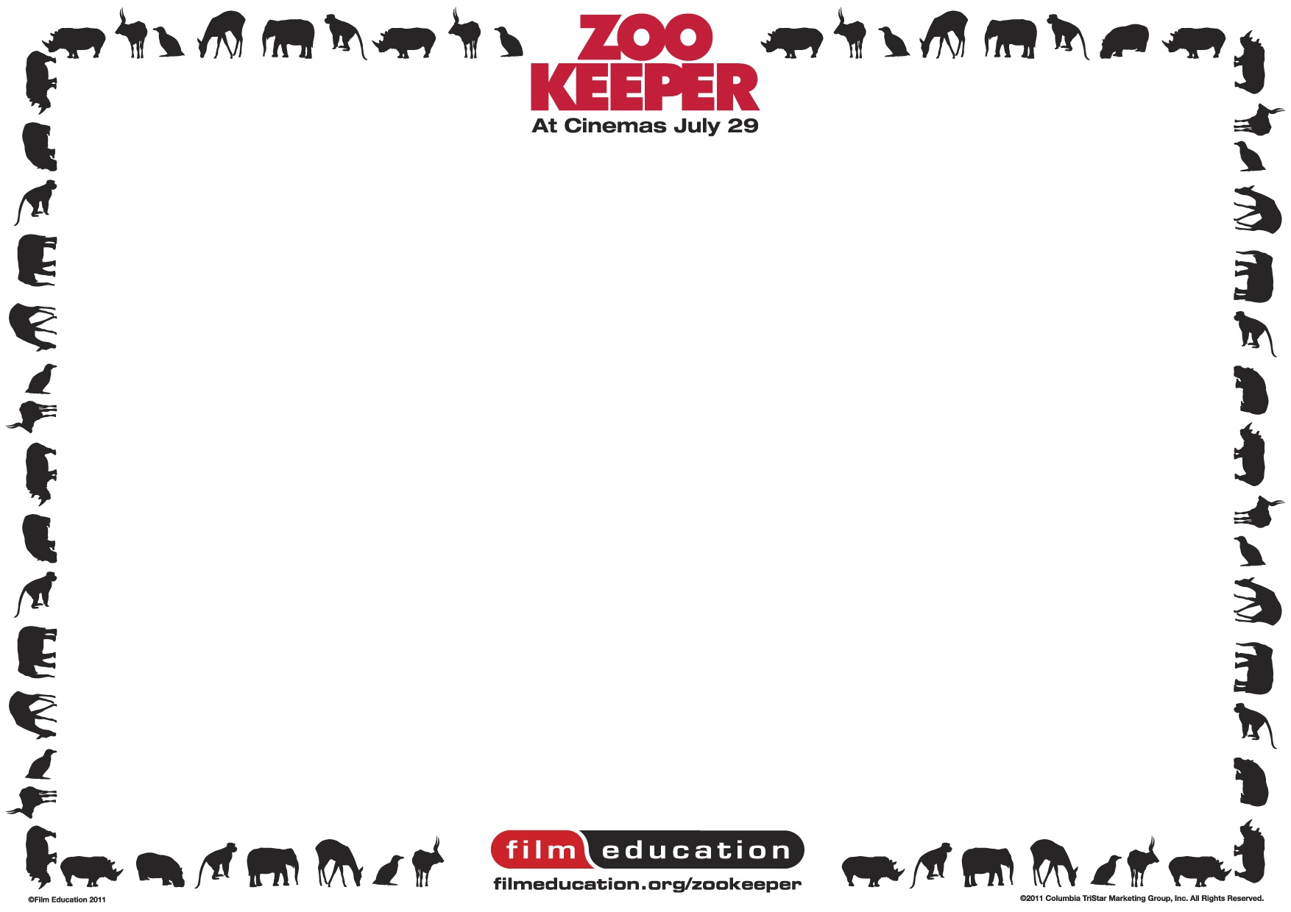

Zookeeper Educational Resource, Teachers’ Notes & Scheme of Work
Subjects: Literacy / Science / Art & Design / Information Communication Technology
Age range: 7-11 year olds Duration: 3-10 weeks
This scheme of work takes into account all elements of Film Education’s Zookeeper activities:
Wallchart / Interactive CD-ROM / Microsite: filmeducation.org/zookeeper

Resource/subject | Pupils will be taught: | Activities | Resources | Assessment opportunities
Wallchart –  Worksheets 1 & 2  ‘Welcome to  his jungle’  Literacy  Science  3-4 hours  Ages 8-11 | Literacy: Film Narrative  Develop a storyboard for the narrative by capturing and importing key images into a presentation programme. Children write their own version of the zoo keeper copying animal behaviour, organising and writing into paragraphs. Extension: create  a multimodal presentation of this version including images, voice-over, soundtrack and written text  Science – Life Processes:  - that the life processes common to humans and other animals include nutrition, movement, growth and reproduction  - to make links between life processes in familiar animals and plants and the environments in which they are found | - investigate behaviour traits of the gorilla; bear; lion or  Capuchin monkey  - create a storyboard depicting the zoo keeper copying the  behaviour of one of these animals | Access to filmeducation.org/zookeeper (for animal information)  Zookeeper wallchart worksheet 2  – storyboard template | Literacy: organise and present whole texts effectively, sequencing and structuring information, ideas and events  Science: Communicating and collaborating in  Science –  across a range of contexts and practical situations pupils will select appropriate ways of presenting scientific data

Resource/ subject | Pupils will be taught: | Activities | Resources | Assessment opportunities
Wallchart –  Worksheets 3 & 4  ‘The Film  Education  Zookeeper  Competition’  Literacy  2 hours  Ages 7-11 | Literacy - to use characterisation to engage readers’ interest | Discuss how the film creates its animal characters (filming techniques, voice, dialogue,  actions)  Use the character profile sheet  (worksheet 4) or create a digital profile | Zookeeper trailer – watch at filmeducation.org/ zookeeper  Zookeeper wallchart worksheet 4  – character profile sheet | Literacy: produce texts which are appropriate to task, reader and purpose
Interactive  CD-ROM –  Talking  Animals  Activity  Literacy  2 hours  Ages 7-11 | Literacy - to use characterisation to engage readers’ interest | Use the ‘thinking, feeling, saying’ function to annotate character screen shots from the film.  Use the character creation section to create a digital profile to enter into the competition | Film Education’s  Zookeeper interactive  CD-ROM | Literacy: produce texts which are appropriate to task, reader and purpose

Resource/ subject | Pupils will be taught: | Activities | Resources | Assessment opportunities
Film Education Zookeeper microsite:  filmeducation.  org/zookeeper  – Competition  – Meet the  Characters  Literacy  2 hours | Literacy - to use characterisation to engage readers’ interest | Pupils will find out about the animal characters from the film Zookeeper and create their own | filmeducation.org/  zookeeper  – competition activity | Literacy: produce texts which are appropriate to task, reader and purpose
Wallchart – worksheet 5  ‘Zealous Zoos’  Science  2 hours  Ages 8-11 | Science – living things in their environment: about ways in which living things and the environment need protection | - create a ‘Did you know?’ fact sheet about animals  - design a poster that highlights the conservation work of zoos | Zookeeper wallchart  worksheet 5  – Zealous Zoos  filmeducation.org/zookeeper (to find out about animals)  Zoological Society of  London website zsl.org/conservation) to find out about the work of zoos in animal conservation | Science: Understanding the Applications Implications of Science  - describe some simple positive and negative consequences of scientific developments; identify aspects of science used within particular jobs or roles

Resource/ subject | Pupils will be taught: | Activities | Resources | Assessment opportunities
Wallchart – worksheet 6  ‘Human  Restaurants’  Literacy  2 hours  Ages 8-11 | Show imagination through the language used to create humour | Create restaurant names and menus that would appeal to different animals | Zookeeper wallchart worksheet 6  – human restaurants | Literacy – select appropriate and effective vocabulary
Wallchart –worksheets 7 & 8  ‘Animal  Artwork  Masks’  Drama  Art & Design  2 hours  Ages 8-11 | Drama: present characters through dialogue and drama to engage the interest of an audience  Art & Design: investigate and combine visual qualities of materials to match those qualities to the purpose of the work | Cut out and colour animal masks as props to use to re-enact some animal behaviour traits | Zookeeper wallchart worksheets 1, 2, 7 & 8  – welcome to his jungle and Animal Artwork masks | Literacy: Speaking and  Listening – talking within role-play and drama
Interactive CD-ROM –  Zookeeper Manual  4 hours  Ages 7-11 | To demonstrate understanding of generic structure and language features of the instructional text  To demonstrate understanding of generic structure and language features of persuasion texts | Create a digital ‘looking after animals’ manual from the point of view of the zoo keeper | Film Education’s  Zookeeper interactive CD-ROM | Literacy: Writing –  produce texts which are appropriate to task, reader and purpose

Resource/ subject | Pupils will be taught: | Activities | Resources | Assessment opportunities
Interactive  CD-ROM –  Zoo Radio  4 hours  Ages 7-11 | To demonstrate understanding of generic structure and language features of persuasion texts | Create a script and recording of a radio advert for the zoo, from the animals’ point of view | Film Education’s  Zookeeper interactive CD-ROM | Literacy: Drama –  talking within role play and drama  Literacy: Writing –  produce texts which are appropriate to task, reader and purpose
Film  Education  Zookeeper  microsite:  filmeducation.  org/zookeeper  – Zoo Radio  advert gallery  Literacy  2 hours  Ages 7-11 | To demonstrate and showcase understanding of generic structure and language features of persuasion texts | Upload, publish and showcase pupil’s finished Zoo Radio adverts to the Film Education website  Explore those created by other school children | filmeducation.org/  zookeeper – Zookeeper  Zoo Radio advert gallery | Literacy: Drama –  talking within role play and drama  Literacy: Writing –  produce texts which are appropriate to task, reader and purpose

Resource/ subject | Pupils will be taught: | Activities | Resources | Assessment opportunities
Film  Education  Zookeeper  microsite:  filmeducation.  org/zookeeper  – Word Cloud activity  Literacy  2 hours  Ages 7-11 | To adapt non-narrative forms and styles to create own texts | Watch the film’s trailer, focus on one animal, write about it and create a word cloud using the interactive programme via Film Education’s website | filmeducation.org/zookeeper  – Zookeeper trailer and word cloud activity | Literacy: Writing –  write imaginative, interesting and thoughtful texts

